Lab 1: REPRESENTATION

Name:

This lab introduces you to some of the principle components of spatial planning: features, targets, and planning units. We will use Tasmania as an example to explore one of the most important themes of any good spatial plan: representation.

A representative reserve is one that captures and protects a sample of all the habitats and important species present. it is a straightforward principle of systematic conservation planning and probably the most important.

We have compiled a dataset of 25 conservation features. We will use these features to explore the themes of spatial prioritization.

15 hypothetical Vegetation types in a hotter and more arid Tasmania

|  |  |  |  |
| --- | --- | --- | --- |
| Macintosh HD:Users:uqjmcgow:Documents:PROJECTS:Marxan_training:Images:acaciaforests.jpg  Acacia Forests | Macintosh HD:Users:uqjmcgow:Documents:PROJECTS:Marxan_training:Images:acaciashrublands.jpg  Acacia Shrublands | Macintosh HD:Users:uqjmcgow:Documents:PROJECTS:Marxan_training:Images:Eucshrub.jpgEucalytpus Shrublands | Macintosh HD:Users:uqjmcgow:Documents:PROJECTS:Marxan_training:Images:eucwoodlands.jpg  Eucalyptus woodland |
| Macintosh HD:Users:uqjmcgow:Documents:PROJECTS:Marxan_training:Images:freshwater.jpg  Freshwater | Macintosh HD:Users:uqjmcgow:Documents:PROJECTS:Marxan_training:Images:grasslands.jpg  Grasslands | Macintosh HD:Users:uqjmcgow:Documents:PROJECTS:Marxan_training:Images:lowforest.jpg  Low Forest | Macintosh HD:Users:uqjmcgow:Documents:PROJECTS:Marxan_training:Images:malleeshrub.jpg  Mallee Shrublands |
| Macintosh HD:Users:uqjmcgow:Documents:PROJECTS:Marxan_training:Images:mulgawood.jpg  Mulga Woodlands | Macintosh HD:Users:uqjmcgow:Documents:PROJECTS:Marxan_training:Images:openshrublands.jpg  Open Shrublands | Macintosh HD:Users:uqjmcgow:Documents:PROJECTS:Marxan_training:Images:saltbush.jpg  Saltbush Shrublands | Macintosh HD:Users:uqjmcgow:Documents:PROJECTS:Marxan_training:Images:saltlagoon.jpg  Salt Lagoon |
| Macintosh HD:Users:uqjmcgow:Documents:PROJECTS:Marxan_training:Images:sedgelands.jpg  SedgeLands | Macintosh HD:Users:uqjmcgow:Documents:PROJECTS:Marxan_training:Images:troprain.jpg  Tropical Rainforest | Macintosh HD:Users:uqjmcgow:Documents:PROJECTS:Marxan_training:Images:tussockgrasslands.jpg  Tussock Grasslands |  |

10 Species distributions from the Australian Species of national environmental significance database

|  |  |  |  |
| --- | --- | --- | --- |
| Macintosh HD:Users:uqjmcgow:Documents:PROJECTS:Marxan_training:Images:bartailedgodwit.jpg  Bartailed Godwit | Macintosh HD:Users:uqjmcgow:Documents:PROJECTS:Marxan_training:Images:blindvelvetworm.jpg  Blind Velvet worm | Macintosh HD:Users:uqjmcgow:Documents:PROJECTS:Marxan_training:Images:claspleathheath.jpg  Claspleath Heath | Macintosh HD:Users:uqjmcgow:Documents:PROJECTS:Marxan_training:Images:FairyWren.jpg  Fairy Wren |
| Macintosh HD:Users:uqjmcgow:Documents:PROJECTS:Marxan_training:Images:hoarysunray.jpg  Hoary Sunray | Macintosh HD:Users:uqjmcgow:Documents:PROJECTS:Marxan_training:Images:orangebellparrot.jpg  Orange-Bellied Parrot | Macintosh HD:Users:uqjmcgow:Documents:PROJECTS:Marxan_training:Images:Swift_parrot.jpg  Swift Parrot | Macintosh HD:Users:uqjmcgow:Documents:PROJECTS:Marxan_training:Images:seaeagle.jpg  Sea Eagle |
| Macintosh HD:Users:uqjmcgow:Documents:PROJECTS:Marxan_training:Images:tasazurekingfish.jpg  Azure Kingfisher | Macintosh HD:Users:uqjmcgow:Documents:PROJECTS:Marxan_training:Images:tasmaskedowl.jpg  Masked owl |  |  |

Now that you are acquainted with our conservation features, let’s get familiar with the marxan.net interface.

* go to http://marxan.net/CONS7021.html and lnk to Activity 1

Throughout these labs, you will be asked to change the parameters in the control panel on the lefthand side of the screen. The display control is located at the bottom of the control panel and will allow you to select the types of outputs to view in the map and table window. These outputs will help you answer the questions in the labs.

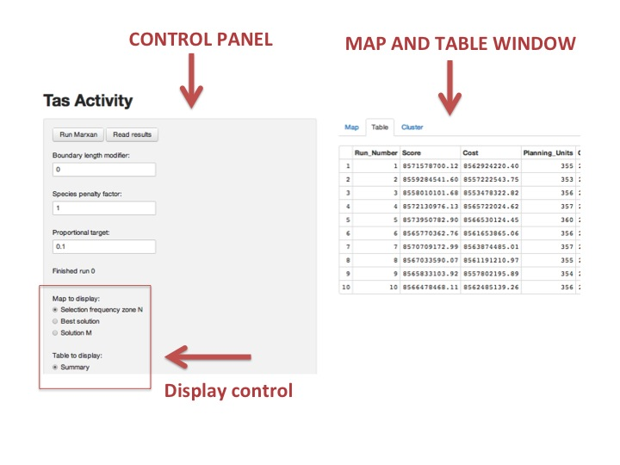

* Take a minute to get acquainted with the key components of the interface; click through the map and table options.
* Now display the table by selecting the Table Tab on the right and make sure the Conservation Features radio button is selected under the Table to Display section. Here is a list of all of our conservation features: 15 habitats and 10 species. the prop field is short for the *proportion*, or target we allocate to each feature that we would like to reserve in our solutions. By default, we have set the targets for the first 10 habitat features to 0.1 or 10%.

Key Terms:

**Conservation Features:** the species or habitats we are interesting in conserving

**Targets:** an explicit goal that quantifies the minimum amount of each conservation feature to be conserved

**Run:** the execution of the Marxan algorithm to find a good solution (#runs = #solutions generated)

**Selection Frequency:** the sum of the times a planning unit was selected to be in the reserve across all runs

(Max Selection Frequency ≤ # runs executed)

**Planning Unit:**  the discrete spatial unit used in conservation planning

* Switch to the Map Tab, view the Selection Frequency and press Run Marxan. While Marxan is running, the “Finished” command will fade to grey. When it is black, the program has finished. In this tutorial version we have programed Marxan to find 10 good solutions to any spatial problem we pose. If you want to view these individual solutions, you can do so by toggling to the Solution M map and using the Solution M slide Bar. The hexagonal shapes inside tasmania are called planning units. These are discrete units that carve up the landscape for planning. each one can be in, or out, of a reserve system.
* Go back to the Table Tab and display the Summary table which gives us quantitative outputs for the ten runs we just executed. The fields show the overall score, total cost, number of planning units and area that are reserved in each of the ten solutions.
* Spend a moment trying to understand this table. What is the relationship of total area to the number of planning units? What Field drives the best solution?

The highlighted row is the best solution of the 10 runs for our first “10 habitat” scenario.

* We will now add one conservation feature at a time, starting with Habitats, then species, until all conservation features are represented in the solutions. In excel, create the table below and after each Marxan run record the values of the best solution for each new scenario.
* To add in another feature, go back to the Conservation Features table in the control panel. Under Choose a species to Edit select the next feature in the list. For this step, it should be saltbush.
* Set the Proportional target to 0.1 and then Save Target. You should be able to see the prop field update with the new value.
* Press Run Marxan again. switch to the Summary Table (which should have been updated) and input the new values in your Excel spreadsheet.
* Repeat these steps until you have set targets for all 25 features and recorded the information in Excel.

|  |  |  |  |
| --- | --- | --- | --- |
| Number of Features | Features Added | Cost of Best Solution | Total Area of Best Solution |
| 10 | “10 habitat scenario” |  |  |
| 11 | Saltbush |  |  |
| 12 | Salt lagoon |  |  |
| 13 | Sedgelands |  |  |
| 14 | Tropical Rainforest |  |  |
| 15 | Tussock Grass |  |  |
| 16 | Azure Kingfisher |  |  |
| 17 | Blind Velvet Worm |  |  |
| 18 | Bartailed Godwit |  |  |
| 19 | Claspleath Heath |  |  |
| 20 | Fairy Wren |  |  |
| 21 | Hoary Sunray |  |  |
| 22 | Masked Owl |  |  |
| 23 | Orange-bellied Parrot |  |  |
| 24 | Swift Parrot |  |  |
| 25 | Sea Eagle |  |  |

In excel, plot the # of features against the total area for the 16 different problems (scenarios) we have solved. Insert the graph with the “features Added” column for the x-axis labels.

What is happening to the area of the reserve system as we increase the number of habitat features? Explain your observation.

What happens when we start to add in species features? Explain your observation.

How did the cost change as we added in more features? Explain your observation.

* Now clear the species features proportions and repeat the last exercise, this time adding the species from those with the smallest distributions first.
* Like before, in excel, plot the # of features against the total area for the 16 different scenarios. Insert the graph.

What is happening to the area of the reserve system as we increase the number of species features? Explain your observation and the difference the two graphs.

If we had complete coverage of vegatation types for Tasmania, how would this change this final exercise?